**Praveen**

**700746128**

**NEURAL NETWORKS AND DEEP LEARNING**

**ASSIGNMENT -3**

1. **Follow the instruction below and then report how the performance changed.(apply all at once)**

As per the given instructions imported necessary modules and loaded the data.

Later, splitted data for testing and training. Added convolutional input layers as given. After that printed the model summary.

Given epoch=5, which will be running 5 epochs and evaluated scores and printed accuracy. The accuracy is 65.29%.

After repeating the same with different convolutional layers, the accuracy got changed to 56.99

Here are the results of the data executed.

1. **Predict the first 4 images of the test data using the above model. Then, compare with the actual label for those 4 images to check whether or not the model has predicted correctly.**

Predicted the first 4 images and the model predicted correctly in which predicted labels are same as actual labels. Here are the screenshots attached below.

1. **Visualize Loss and Accuracy using the history object**

Using matplotlib, plotted the history object loss and accuracy.

Here are the visualization results below.

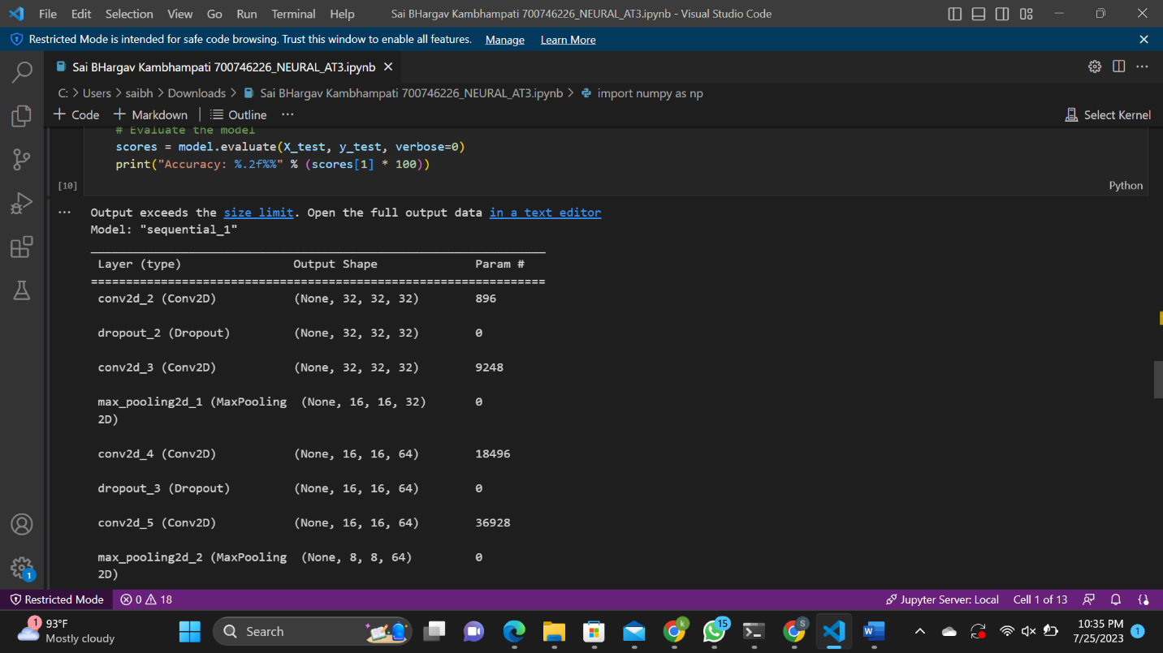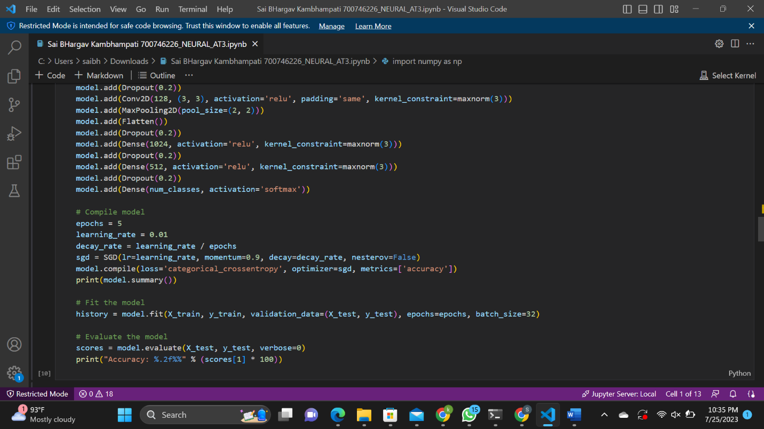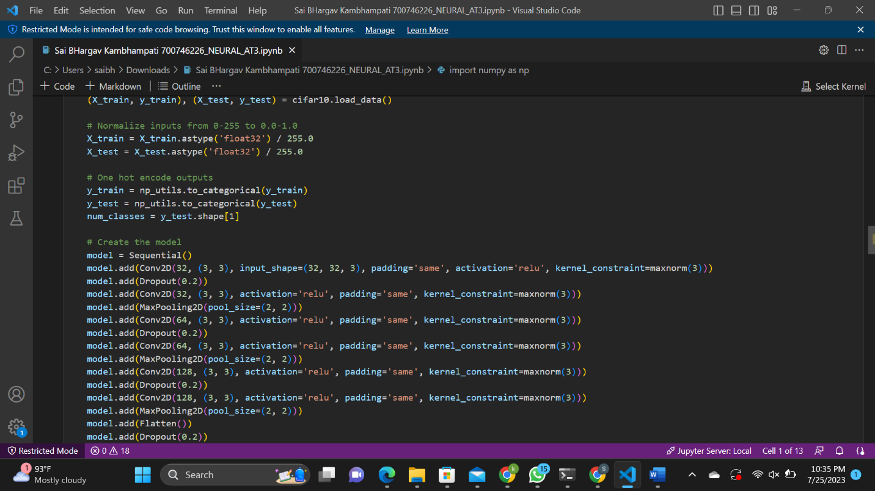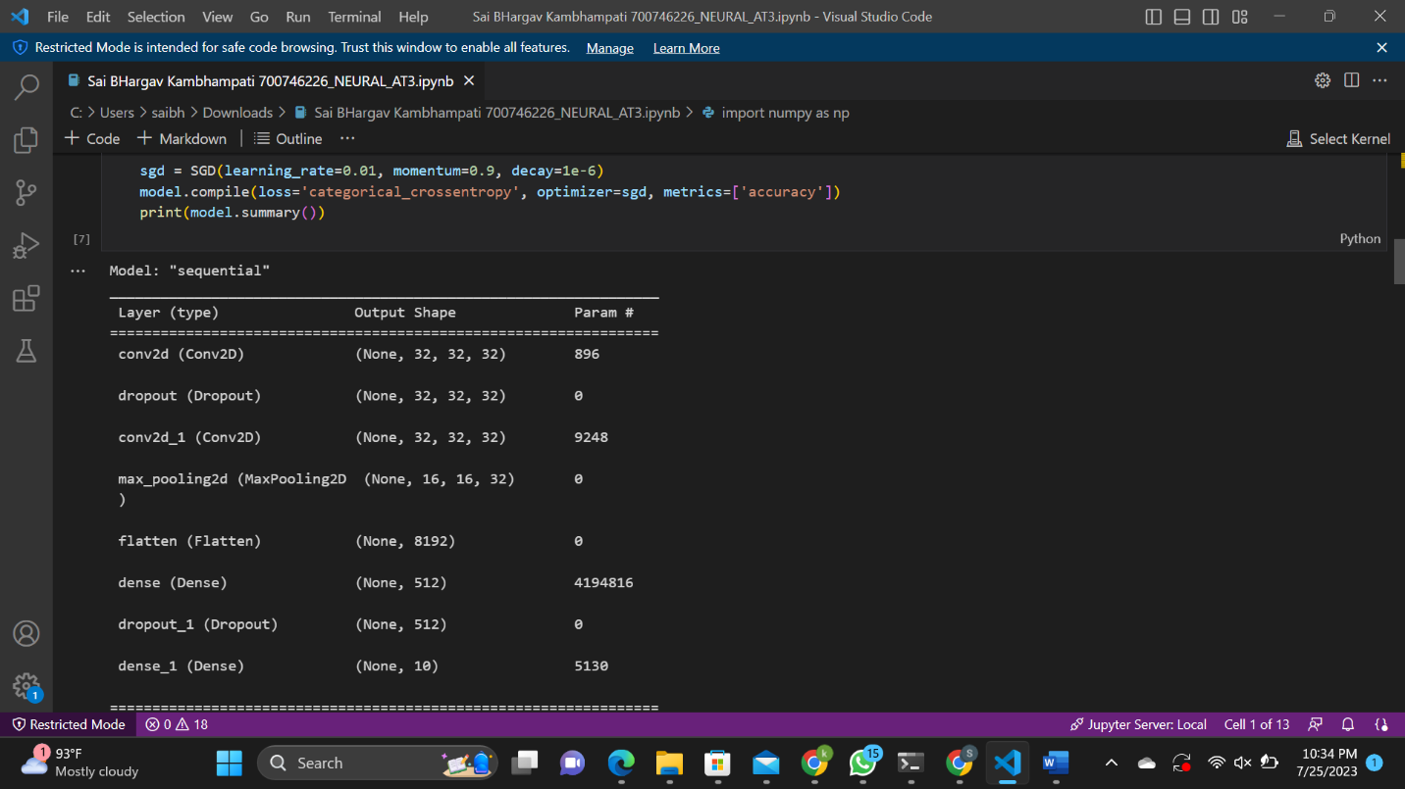

**GithubLink:**

https://github.com/kambhampa/Neural_AT2/blob/main/Sai%20BHargav%20Kambhampati%20700746226_NEURAL_AT3.ipynb

**Video Link**

**https://github.com/kambhampa/Neural_AT2/blob/main/Sai%20BHargav%20Kambhampati%20700746226_NEURAL_AT3.ipynb%20-%20Visual%20Studio%20Code%202023-07-25%2022-45-21.mp4**